Cloud Computing Assignment 3: Introduction to AWS S3

Name: Naren Chandrashekhar

SRN: PES2UG20CS216

Section: D

**In Lab 1:**

Screenshot 1a: Bucket Creation

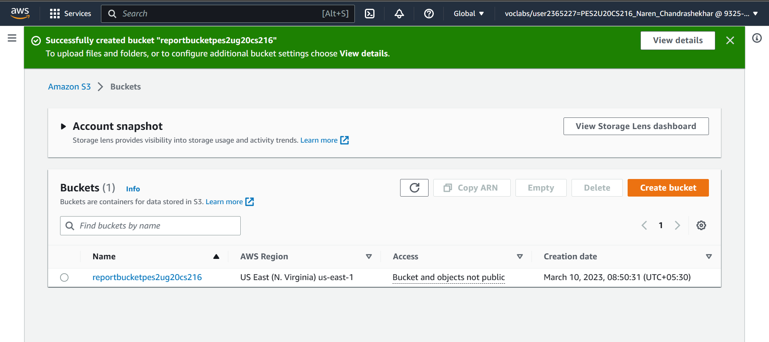

Screenshot 1b: Access denied error when opening new-report.png

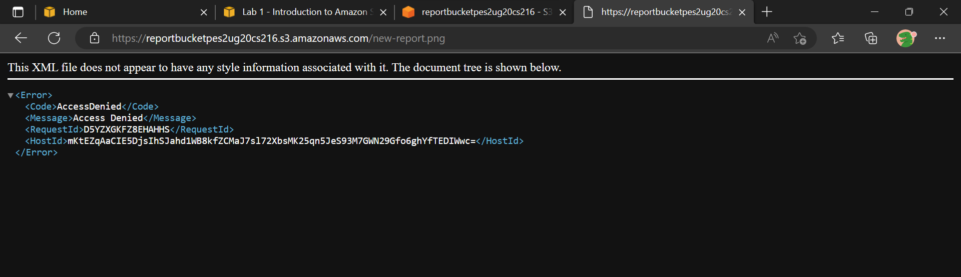

Screenshot 1c: Display new-report.png after making it publicly accessible

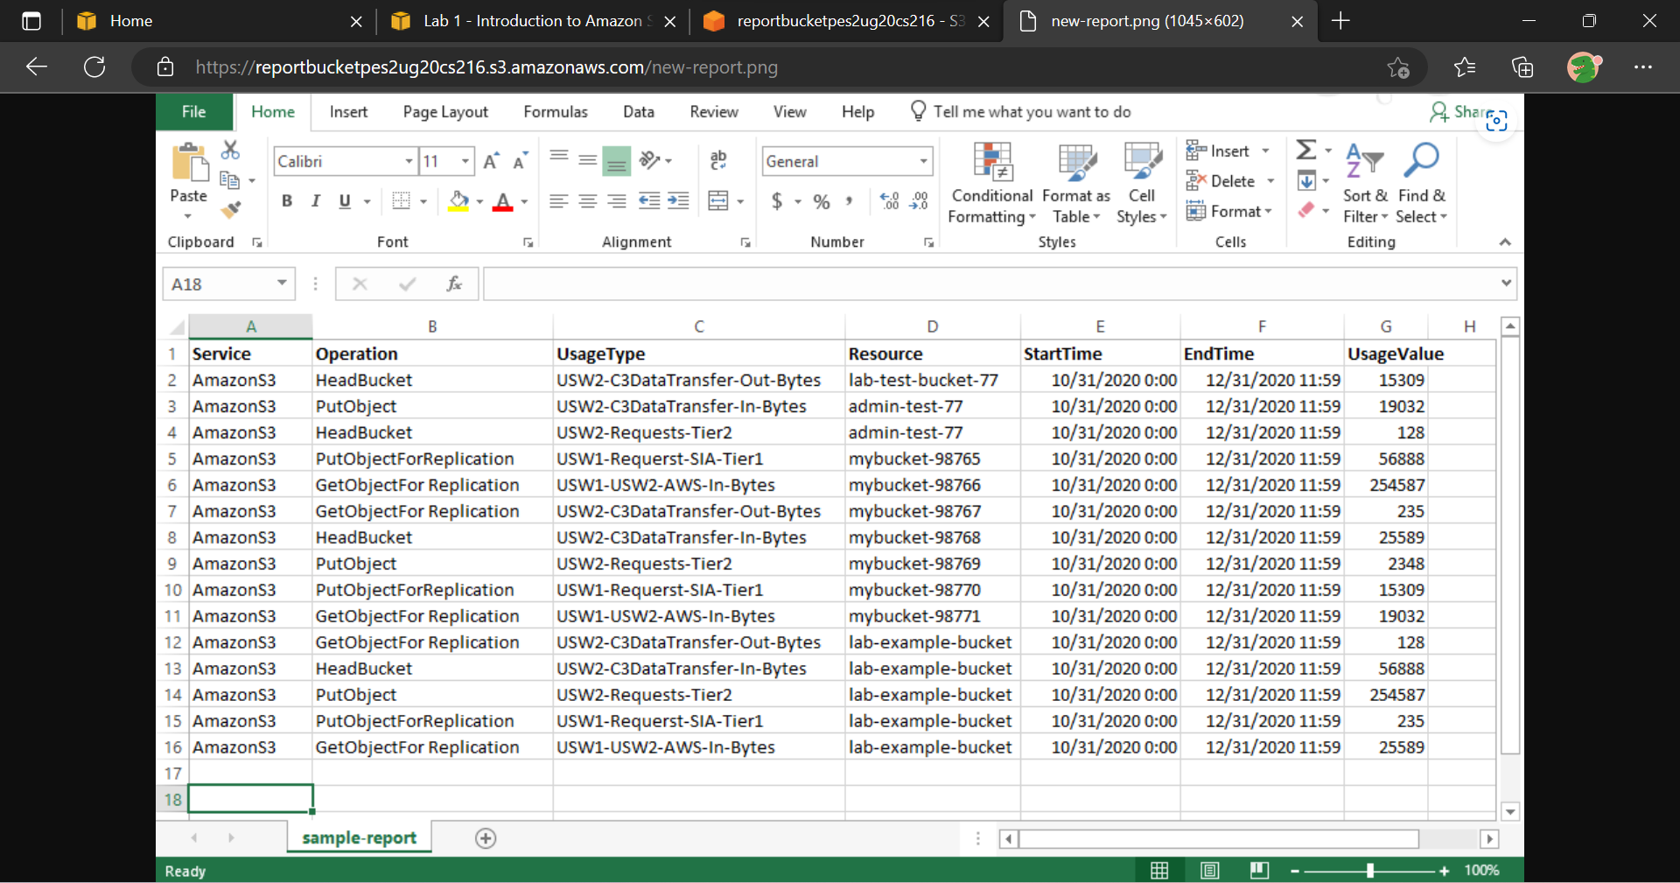

Screenshot 1d: PutObject operation failed (Access Denied)

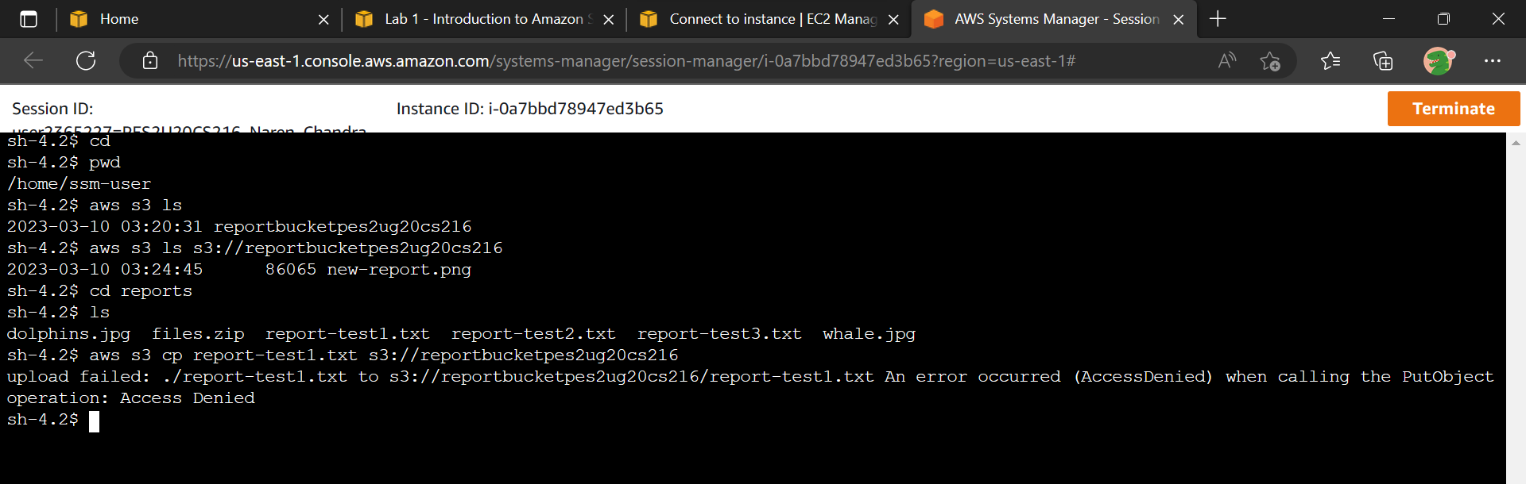

Screenshot 1e: Access denied error when opening sample-file.txt

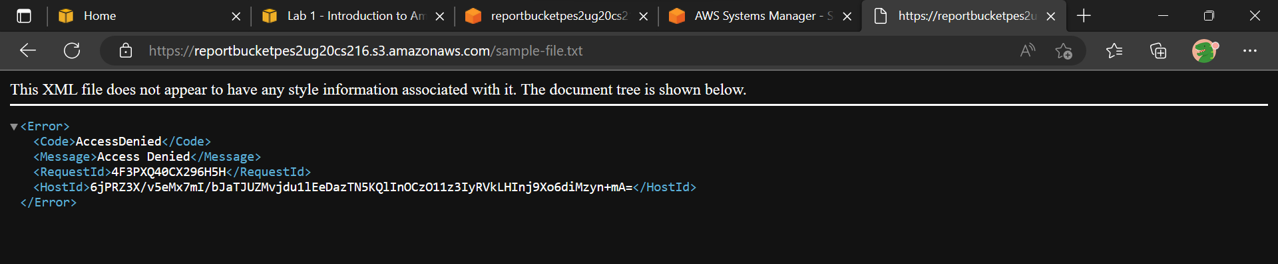

s  
Screenshot 1f: Display sample-file.txt after updating policy

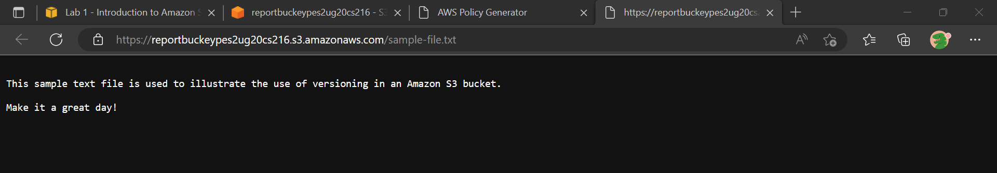

**In Lab 7:**

Screenshot 2a: Enabled static website option selected under “Edit static website hosting”

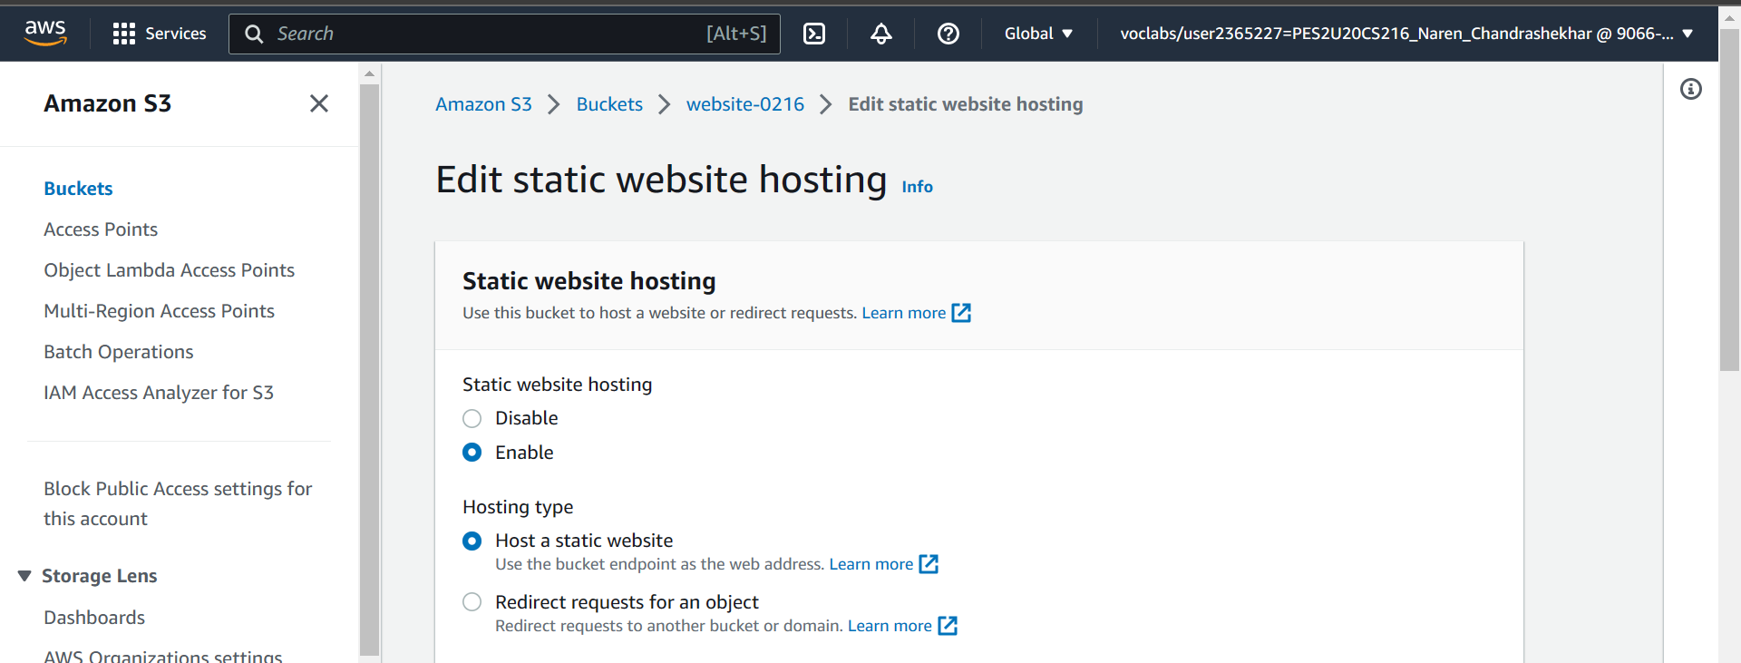

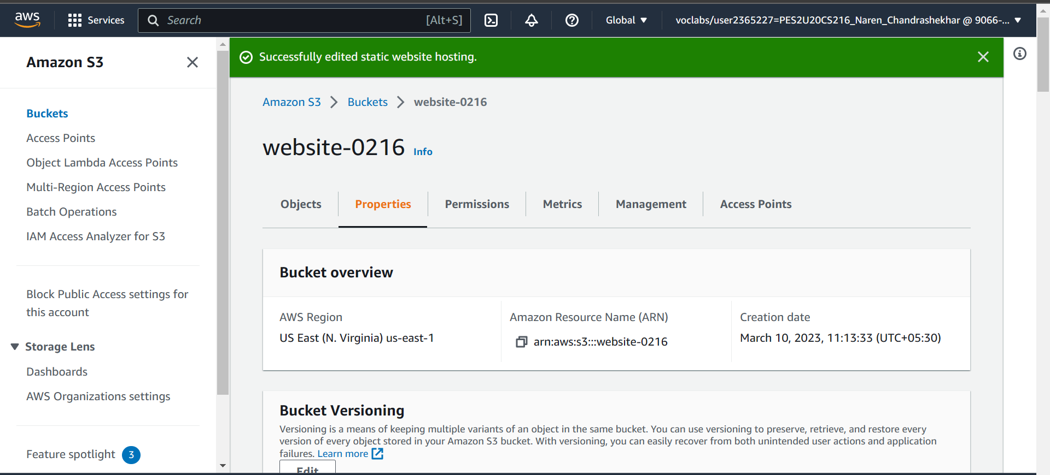

Screenshot 2b: 403 Forbidden Error page

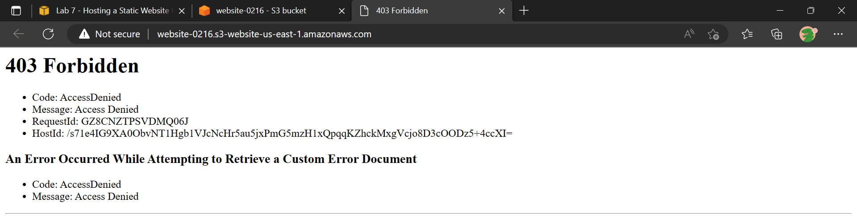

Screenshot 2c: Uploaded objects (index.html, script.js, style.css)

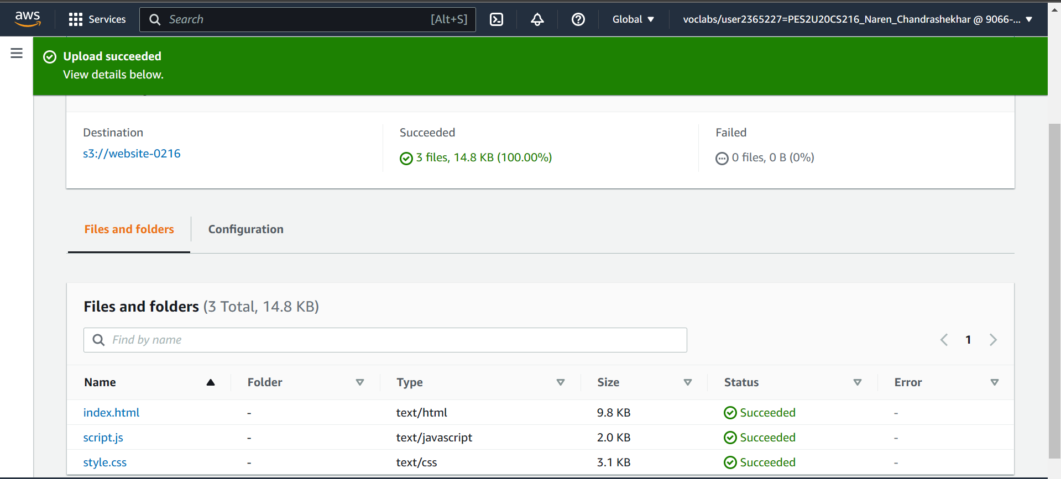

Screenshot 2d: Static website before modifying index.html file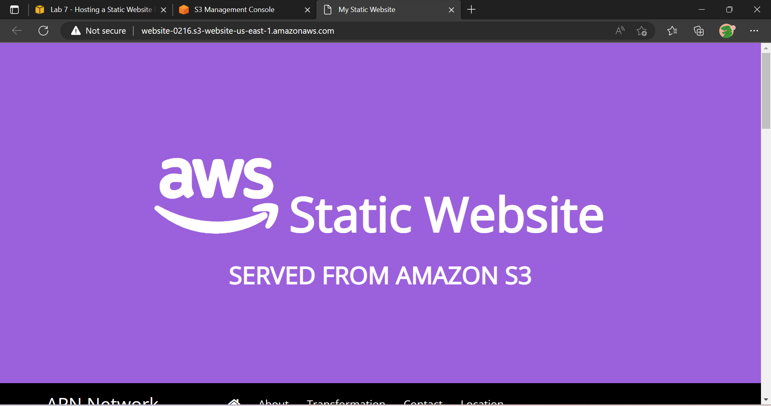

Screenshot 2e: Static website after modifying index.html file

